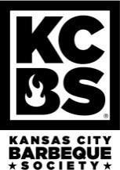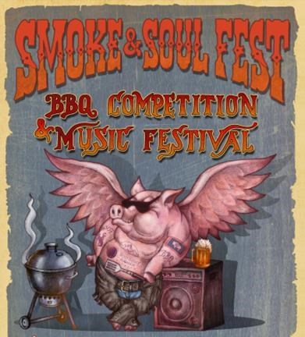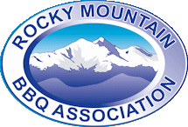

2022 KCBS COMPETITION APPLICATION
Smoke & Soul Fest Community event with Calcutta, competition, and awards

Mail application and entry fees to:
Smoke and Soul Fest
Brain Injury Advocates of Wyoming l PO Box 2984 l Casper, WY 82602
For more information call Brandy at (307) 473-1767 or brandy@wybia.org.

We will not accept any application without payment.

Team Name:________________________________________________________________________________________
Pitmaster:____________________________________________ KCBS #(if applicable):______________________________
Address:
City: _____________________________________________________ State: _________ Zip:_____________________
Phone:____________________________ Email:___________________________________________________________
Four Meat Competition
- October 8, 2020 $ 300.00
- $25 discount if registered and paid by August 15, 2022
- $25 discount for participating in the People’s Choice Tasting Tent

Total Due:___________

▪ Meats include Pork Ribs, Pork (Boston Butt or Shoulder), Brisket, and Chicken.
  - Must adhere to KCBS rules. For a list of rules, please visit https://mms.kcbs.us, or contact Brandy Teague at brandy@wybia.org to get a copy.
  - Each site has power, water and sewer. There is a bath house on site.
  - Early arrival available Thursday, October 6th starting at 12:00pm.
  - Check here if you are arriving on Thursday

- People’s Choice Tasting Tent – help us raise money for The Brain Injury Advocates of Wyoming and receive a $25 DISCOUNT (available for October 2 event only)
- Wow the crowd with your amazing BBQ skills! You give us your BBQ and we will take care of the rest.
- Check here if you are willing to donate your leftover competition meats. Yes
- I will cook ________ additional Pork Butts provided by BIAW to be served in the People’s choice tasting tent.
- Tasting Tent will provide a ballot for each person to choose their favorites and then see how their choices aligned with the judges choices.
- The Brain Injury Advocates of Wyoming is a 501(c)3 non-profit and a donation receipt will be provided upon request.

BBQ Team Vendor - 80/20 Split on Sales – Contact Brandy Teague at 307-473-1767 if interested
  - Must vend BBQ items to the public from 11:30 AM until 6:30 PM on Saturday.
  - We will locate your team in premium location close to the public.
  - Maximum of 2 vendors

Payment Type
Make checks payable to: BIAW Payments can be made on our website www.wybia.org
- Cash □ Check #
□ Credit Card #__________________________ Exp _____________ CVV______ Zip Code______________
Application Process: This is an application only, it does not guarantee acceptance. You will be notified of your status. We will not process your fees unless you have been accepted. Once accepted, we will deposit your fees, and you will receive an acceptance letter and participant packet with more information. This application is non-transferable and the entry fee is non-refundable.
Waiver of Liability: In consideration of your accepting this entry, I, the undersigned, intending to be legally bound, hereby for myself, my heirs, executors, and administrators, waive and release any and all rights and claims for damages I may have against the Brain Injury Advocates of WY, their benefactors, representatives, successors, and/or assigns, for any and all injuries suffered by me in this event. I agree to abide by the KCBS rules, regulations, and judging procedures as well as any and all rules, laws, and guidelines established by the Smoke & Soul Fest. Further, I hereby grant full permission to Smoke & Soul Fest and/or agents authorized by them, to use any photographs, videotapes, motion pictures, recordings, and any other record of this event for any legitimate purpose.

_____________________________________________
Signature of Pitmaster Date

